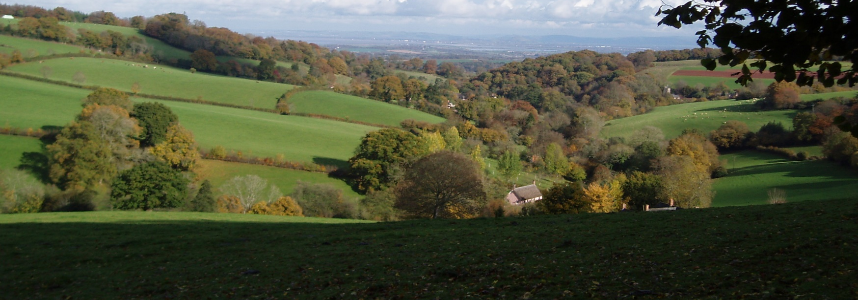

Farming in Protected Landscapes - the Quantock Hills
Protected Landscapes - our National Parks and Areas of Outstanding Natural Beauty - are special and unique places. They are living, working landscapes that also support a huge range of habitats and species, and they are enjoyed by millions of people every year. By supporting the farmers, land managers and people who live and work in these areas, we can help protect these exceptional places and support local communities.
To help do this, Defra has introduced the Farming in Protected Landscapes programme, which will run from July 2021 to March 2024.
Through the programme, farmers and land managers can be supported to carry out projects that support nature recovery, mitigate the impacts of climate change, provide opportunities for people to discover, enjoy and understand the landscape and cultural heritage, or support nature-friendly, sustainable farm businesses. This is a programme of funding for one-off projects within these areas of work, not an ongoing agri-environment scheme.
The programme is part of Defra’s Agricultural Transition Plan. It has been developed by Defra with the support of a group of AONB and National Park staff from across the country.
In the Quantock Hills, the AONB Service will be awarding £280,000 between now and the end of March 2024.

Eligibility
The Farming in Protected Landscapes programme is open to all farmers and land managers (including from the private, public and charity sector) in the Quantock Hills AONB - or anywhere activity on the ground can bring benefit to the AONB.
You must manage all the land included in the application, and have control of all the activities you’d like to undertake, or you must have written consent from all parties who have this management and control.
Other organisations and individuals can apply, as long as they do this in collaboration with a farmer or land manager, or in support of a farmer or group of farmers.
The programme supports activity on any land within the Quantock Hills AONB. It can also support activity on other land where projects can demonstrate benefit to the Quantock Hills, or the Quantock Hills AONB’s objectives or partnership initiatives. It is expected that most of the funding will be provided to projects within the AONB boundary.

You can see the AONB boundary by visiting the MAGIC mapping website. Click on ‘designations’, ‘land-based designations’ and then ‘Areas of Outstanding Natural Beauty England.’

Page 3 of the Guidance for Applicants – see Quantock Grants & Funding (quantockhills.com) - has more details on eligibility.

What the Programme will pay for
The Farming in Protected Landscapes Programme will pay for projects that, in the opinion of the Local Assessment Panel (see ‘Application assessment’ below) provide value for money and meet at least one of the outcomes listed below, under four themes.

Your project must also help to deliver at least one of the objectives of the Quantock Hills AONB Management Plan. Details of these objectives can be found at Quantock Hills AONB Management Plan .
For example, the programme might support:
- Re-wriggling a straightened watercourse, for the biodiversity and natural flood management benefits this can bring
- Replacing stiles with gates on public footpaths to promote easier access
- Creating wader scrapes, or creating ponds to support a variety of wildlife
- Promoting connectivity between habitats
- Conserving historic features on a farm, such as lime kilns or lead mining heritage
- Supporting a locally-branded food initiative which promotes the links between the product and the landscape in which it is produced
- Re-wilding an area of land and promoting natural processes
- Action to reduce carbon emissions on a farm
- Whole farm planning for conservation, energy efficiency and economic resilience, including in farmer clusters
- Gathering data and evidence to help inform conservation and farming practice

Payment rates
If an applicant will not make a commercial gain through a project, they could receive up to 100% of the costs.
Where an applicant would benefit commercially from a project, they could receive between 40% and 80% of the costs through the Programme, depending on how much commercial benefit the project will give them.
The Programme will work alongside – not in competition with – Defra’s existing and new schemes, adding value where it is most needed. If a potential project can be rewarded through those schemes instead, you will be made aware of them.
If an activity is equivalent to one under Countryside Stewardship (CS), the Programme payment rate will be the same as the CS rate. If not, we will base Programme funding offers on the projected costs of an activity (with final payments made against evidenced costs).

Maintenance agreements
Capital infrastructure assets (including, but not limited to, fences, gates, building restoration), should be maintained for 5 years from the date of completion.
Machinery assets (for example a brush harvester for grassland restoration) should be maintained for 5 years from the date of purchase.
The requirement to maintain natural, cultural and access activities (for example, management of grassland, restoration of a limekiln) delivered as part of programme will cease no later than 1 April 2024.
More detail on this can be found in the National Framework.

How to apply
Before applying please contact us to discuss project ideas. Then to apply, please fill in an application form - Quantock Grants & Funding (quantockhills.com). Applications for the first year of Programme funding should be made between 1st July 2021 and 31st January 2022. Funding will be awarded to successful applicants throughout the application window, rather than after the window closes, so you should submit your application as soon as it is ready.
We will also consider applications for funding in year 2, especially if they aim to begin early in the financial year.
Multi-year awards are possible for longer projects. All projects must end by March 2024.
Before applying, we would encourage you to contact us to discuss your application. Ideally, the Farming in Protected Landscapes project officer will visit your potential project location or meet you to discuss your ideas.

Application assessment
Applications for over £5000 will be judged by a Local Assessment Panel. This kind of system has been used locally before for the Greater Quantock Landscape Development Fund.
The Local Assessment Panel will be made up of 8 to 12 people. It will include representatives from the Quantock Hills AONB JAC, Natural England, representatives from the farming and land management community, and landscape and biodiversity specialists.
We expect that the panel will meet to make decisions every 6 to 8 weeks.
Applications for less than £5000 will be decided upon by a senior member of the AONB team (who has no prior knowledge of the project).

More information
- Visit the Quantock Hills AONB website for more information, including about our other work
- Read the Guidance for Applicants Quantock Grants & Funding (quantockhills.com) (including detail on the eligibility criteria and decision-making process)
- Download an application form Quantock Grants & Funding (quantockhills.com)
If you have a question about the Farming in Protected Landscapes Programme, please email Katie Read, Landscape Project Officer at czread@somerset.gov.uk, or call on 07977 412249.

Quantock Hills Area of Outstanding Nature Beauty (Blue boundary)
